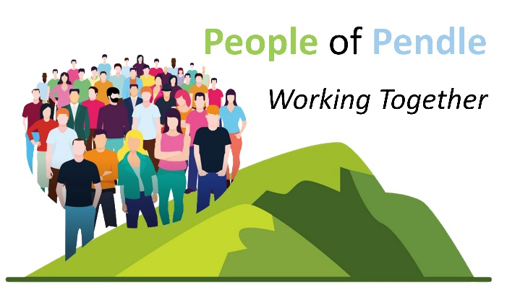
Meeting
Online
28th July 2025 at 2 p.m.
Agenda
 |  | Time
1. | Welcome | 2.00 p.m.
2. | Spotlight:  - Lisa Ross - Volunteering for Health (LACVS)  - Anne Edington - Homestart | 2.05 p.m.
3. | Pendle Health and Wellbeing Partnership Update  - Update on Lancashire County Council Adult Social Care –  Social Connections Project  - Update on People of Pendle Health Gathering – Gill Dickson  - Regular collection of feedback from members of People of Pendle to feed into the Health and Wellbeing Partnership on emerging key priorities/themes as seen by members’ organisations | 2.25 p.m.
4. | Acts of Kindness – Please bring along your act of kindness, large or small – it can be something you do regularly, have done in the past or plan to do in the future. Help BPRCVS to fill their Kindness Tree in celebration of their 90th Anniversary or send them to tom.knowles@bprcvs.co.uk | 2.35 p.m.
5. | Information Sharing: A chance for members to give updates on their projects,  events, etc | 2.40 p.m.
6. | Next meeting: 18th August 2025 – 2 p.m. – Online
7. | Thank you
 | Meeting ends | 3.00 p.m.
Join Zoom Meeting
https://us02web.zoom.us/j/87418688400?pwd=cobHyP0fNkNfg88PkfwtxTjIGbFakd.1
Meeting ID: 874 1868 8400 Passcode: 683880
Thank you for being a part of People of Pendle – making connections throughout Pendle and beyond!
Please do encourage anyone delivering projects in Pendle to become a member: email lorna.powell@bprcvs.co.uk for a Membership Form and an invitation/link to the meetings

