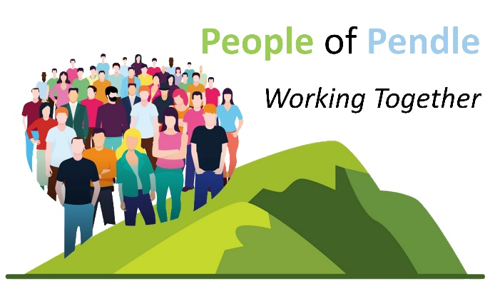
Meeting
Online
24th February 2025 at 2 p.m.
Agenda
 |  | Time
1. | Welcome | 2.00 p.m.
2. | Pendle Health and Wellbeing Partnership Update  - Update from the Partnership – Gill Dickson  - Regular collection of feedback from members of People of Pendle to feed into the Health and Wellbeing Partnership on emerging key priorities/themes as seen by members’ organisations | 2.05 p.m.
3. | Information Sharing: A chance for members to give updates on their projects,  events, etc | 2.15 p.m.
4. | Next meeting: 31st March 2025 – 2 p.m. - online
5. | Thank you
 | Meeting ends | 3.00 p.m.

Join Zoom Meeting
https://us02web.zoom.us/j/82069586378?pwd=4VlROtsMEbOuJwuNMxiKRFUdgfzMla.1
Meeting ID: 820 6958 6378 Passcode: 845769
Thank you for being a part of People of Pendle – making connections throughout Pendle and beyond!

Please do encourage anyone delivering projects in Pendle to become a member: email lorna.powell@bprcvs.co.uk for a Membership Form and an invitation/link to the meetings

