  - 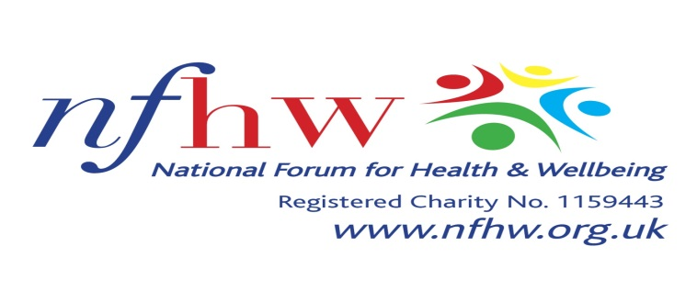

Dear colleague

16^{t} May 2026

We are hosting our Third Health Mela at the University Of Central Lancashire, Victoria Mill Campus, Trafalgar Street, Burnley, BB11 1RA.

On behalf of National Forum for Health and Wellbeing and other organizers, I wish to extend this invitation to you and your representatives to participate in the event. Please complete the attached reply slip and either e mail it back to me or post it to Mr. R. Shah by the due date.

The Health Mela starts at 11 AM and finishes at 3 PM.

Breakfast meeting for invited guests and exhibitors will be from 10 AM – 11 AM
Venue will be open from 8 .00 AM onwards for the exhibitors to set up prior to attending the breakfast meeting.

There are car parking facilities around the University Campus and also at Victoria Mill and walk down to Newtown Mill which is only 5 minutes walk. .

Please Note that No Exhibitor will be allowed to sell any items on the day.

Photographs and video will also be taken throughout the course of the Health Mela event, so if you do not wish to appear in any photographs, or on film, please mention it to a member of the Health Mela team on the day.

We look forward to seeing you on the day.

Yours faithfully
Romesh. Gupta
Professor R.C. Gupta OBE
Chairperson

We will/will not* be able to participate in the Health Mela on Saturday 16st May 2026

Contact Name __________________________________________

Organisation name/address _________________________________________________________________________

Telephone: _________________________ Email: ____________________________________________________

Please respond by Friday 1st May 2026 to Ravindra Shah, National Forum for Health & Wellbeing, 19 Ashleigh Court, Fulwood, Preston, PR2 9WU. OR Email: ravin.shah@nfhw.org.uk

