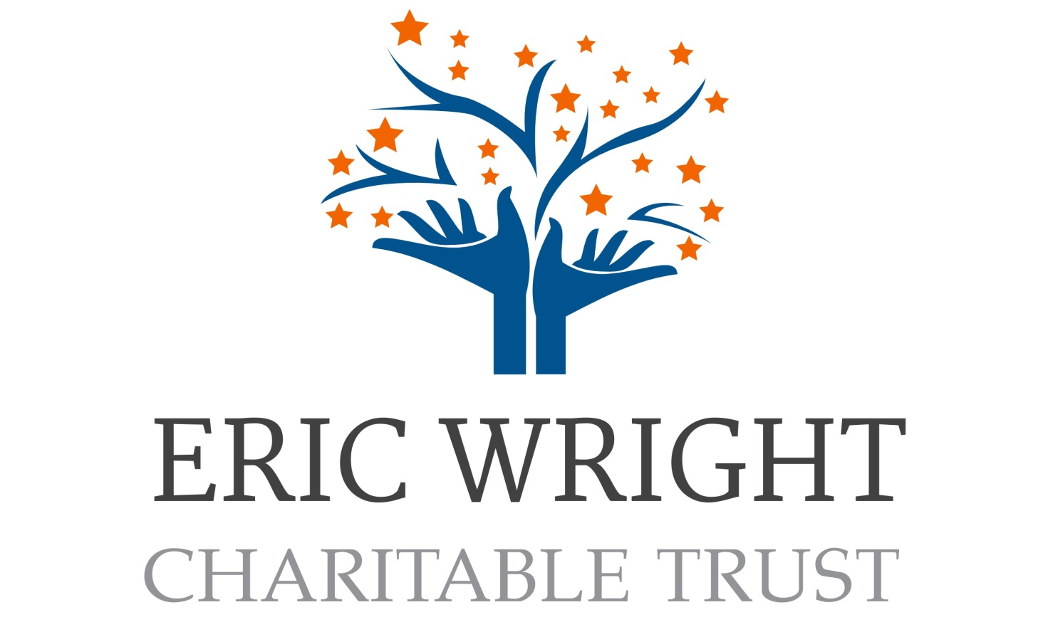
Small Grants Programme 2025/6


Application Form
Please read guidance notes
Applicant - Organisation
Project Name
Application number |  |  | EWS25/ | Date Received
 |  |  | EWS25/ | Amount Req (£)
 |  |  | EWS25/ | Amount offered
Unsuccessful |  |  | Successful
Burnley |  | Pendle |  | Rossendale

Please refer to the guidance to help you to complete this form

Section One – Group and Project Details

Name of Group
Name of Project/Activity
Where is your group based? (address)
When was your group established?
How many people are involved in the group? |  | Committee |  |  |  |  | Volunteers
 |  | Paid Staff |  |  |  |  | Members
Grassroots Grant 
Community Grant 
Longer-term project Grant 
Please note: You must have a proven track record of delivering this kind of project before your application for longer-term funding will be considered.
For a Community Grant your group should have a set of rules or a constitution - please supply a signed copy.

New Group? 
(If you don’t have the above, please contact BPRCVS for support and guidance)
Your group must have procedures to cover equal opportunities and child and vulnerable adult safeguarding.
Please enclose a signed copy
(If you don’t have the above, please contact BPRCVS for support and guidance)
Annual Turnover |  |  | £ |  |  | Please send a recent copy of your accounts
Signature | Name in Block Capitals |  |  |  | Position in Group

Section Two – Contact Details
(Section Two is confidential and will be used for administrative purposes only – please see disclaimer below)
Contact Name
Details of the person who is able to discuss this application.
Contact’s position within the group
Address of contact (if different from group address)

Postcode
Preferred contact  Please enter your preferred method(s) of contact | Email
 | Home
 | Work
 | Mobile
Group Bank/Building Society Name
Address

Postcode
Cheques payable to:

In accordance with GDPR the data you have provided will be stored safely and securely in BPRCVS’ file storage. The purpose of this data is for BPRCVS to access group/organisation details, including contact details, to determine the award of funding and inform of the decision. Your records are completely confidential and only BPRCVS staff and relevant volunteers will have access to them. We are required to share this data with the named funder for monitoring and evaluation purposes. No information will be shared with other third parties without prior agreement. BPRCVS will store this data no longer than our funder’s requirements. To view your rights as the Data Subject please visit BPRCVS’ privacy policy at www.bprcvs.co.uk/index.php/privacy-policy, printed copies available on request.

Section Three – Project Details

Name of project/activity.

What is your project / activities / event going to do?

How long will your project run? E.g. how many sessions/weeks

Who & how many individuals will benefit from the project/activity?

How many volunteers will support your project

What problems in your community will your project help to address?

Where and when will the project/activity take place?

How will you know the grant has made a difference to the people your project will be supporting?

If you are applying for a GRASSROOTS GRANT, how are you working with the CVS?

Additional Information

Which district will your project be delivered in?

Burnley

Pendle

Rossendale

Section Four – Financial Details
Please provide a detailed breakdown of how the grant will be spent and enclose any evidence of money needed, e.g., estimates, quotations.
Please note only 15% of the overall costs are permitted to be capital spend and only 5% of the total costs are permitted for management costs
ITEM | COST
How much money do you require in total to provide your project/activity? (A) | £ | P
How much money are you requesting from Eric Wright Charitable Trust Fund (B)
If A is greater than B, where will the additional funding come from?

Section Five – Signposting Consent
The nature of your project will, from time to time, require referrals and partnership working. Please sign here to give BPRCVS permission to share your given details with relevant third parties only in connection with your project/group activities.
Signature
Date:

Section Six – Equal Opportunities Monitoring Form
Name of Organisation
Location of Activities
The above-named organisation is set up to develop and promote voluntary/community/faith sector activities. We recognise that, in our society, both groups and individuals have been, and continue to be, discriminated against. Therefore, we aim to secure genuine equality of opportunity in ALL aspects of its activities. The following statement aims to ensure that no group or individual receives less favourable treatment or is disadvantaged by conditions or requirements that cannot be shown to be justifiable.
The above-named organisation opposes discrimination on the grounds of age, race, gender, status, sexual orientation, religion, disability, marital status, income or circumstances, language, HIV or other health related issues, and ALL forms of direct or indirect discrimination that restricts or hinders the promotion of equal opportunities. The organisation is committed to achieving equal opportunities in all aspects of its existence, by compliance with, and in the spirit and ethos of equal opportunities legislation.
Signature
Date

Eric Wright Charitable Trust Grant
DECLARATION, please ensure two non-related people authorised to sign on behalf of your group sign the application form.
I confirm that the information contained in this form is accurate.
 | First Representative | Second Representative
Name in block capitals
Signature
Position in group
Date

Application Checklist
Have you included the following with your application? | Yes | No
A fully completed application form
Your group’s rules or constitution (Community Grant Only)
Your group’s annual accounts/financial breakdown/forecast
Your bank account has at least two unrelated signatories
A copy of your group’s Safeguarding policy
All other relevant documents

Please return your completed application form to:
Heather Starkie /Julie Overson
Eric Wright Charitable Grants.
Burnley, Pendle & Rossendale Council for Voluntary Service
The CVS Building
62/64 Yorkshire Street
Burnley
BB11 3BT

Tel: 01282 433740 – ext. 1018 E-Mail: heather.starkie@bprcvs.co.uk

