ELHT National PLACE Assessment 2026

(Patient Led Assessment of the Care Environment)

Introduction

National PLACE Assessment Annual assessment.
Patient-led assessments of the care environment (PLACE) help organisations understand how well they are meeting the needs of their patients and identify where improvements can be made. They take place across NHS trusts, voluntary, independent, and private healthcare providers and use information gleaned directly from patient assessors to report how well a site/organisation is performing.
PLACE is the only national assessment programme that collects data relating to the patient environment and the only process that provides a consistent approach so that all providers are assessing the same things to the same standards.
PLACE helps organisations understand how well they are meeting the needs of their patients and identify where improvements can be made.
It is recommended that all NHS trusts, voluntary, independent, and private healthcare providers undertake annual PLACE assessments of the quality of non-clinical services and condition of their buildings to look at:
PLACE aims to promote the principles established by the NHS Constitution that focus on areas that matters to patients, families, and carers:
- Putting patients first
- Active feedback from public, patients and staff
- Adhering to the basics of quality care
- Ensuring services are provided in a clean and safe environment that is fit for purpose.

PLACE assesses a number of non- clinical aspects of the Healthcare premises identified as important to by the patients and public, known as Domains:
- Cleanliness
- Food and Hydration
- Privacy, dignity, and wellbeing
- Condition, appearance, and maintenance
- Dementia: how well the needs of patients with Dementia are met
- Disability: how well the needs of patients with a disability are met

Would you like to be a patient assessor?
The assessments give patients and the public a voice that can be in the drive to give people more influence over the way their local health and care services are run and in the way in which they are held to account.
Assessment teams are a collaboration between staff and patient assessors, with patient assessors making up at least 50 per cent of the assessment team. Anyone who uses the service can be a patient assessor, including current patients, their family and visitors, carers, patient advocates, or patient council members. NHS foundation trust governors can also be patient assessors.
Staff working in a hospital cannot undertake assessments there as patient assessors, though they are able to act as patient assessors at hospitals in other NHS trusts or elsewhere. Similarly, those who have recently left employment in a hospital/trust should not return as a patient assessor until a suitable period (normally two years) has elapsed.
If you are interested in becoming a patient assessor volunteer and would like to support your local Trust with this year’s assessment, please contact your local Healthwatch group or ELHT PLACE Lead Lisa Grendall or Amy Jane Nesbitt, we look forward to working with you on this important annual assessment.

Please also indicate which is your preferred training session you would like to attend.

PLACE Development Sessions – PLACE Assessors

National PLACE Development sessions and guidance will be provided to support the Patient and staff Representatives by the Trust PLACE Lead, between (August- September 2026), refer to the planned training sessions.
PLACE Assessor Development Sessions – New PLACE Assessor (3hr session)

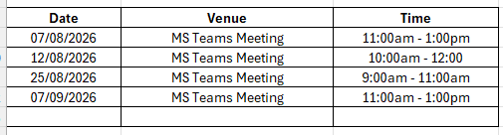

PLACE Assessor Development Sessions – Experienced PLACE Assessor (1hr session)
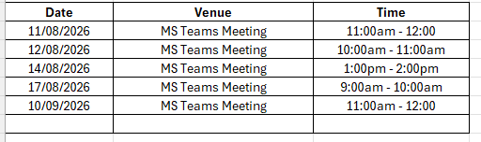
Trust Contact Details:
Lisa Grendall – Associate Director of Facilities: lisa.grendall@elht.nhs.uk
Supportive Documents – New documentation for 2026 has not been released at this point – please review national PLACE Assessment 2025 documentation link below for information and guidance.
https://digital.nhs.uk/data-and-information/areas-of-interest/estates-and-facilities/patient-led-assessments-of-the-care-environment-place

