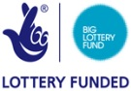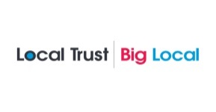

Community Fund – Guidance Notes

**What is it all about?**

Bradley Big Local is a resident led Lottery funded programme. The Bradley area was awarded £1m from the Big Lottery to be invested in the area over the next 10 years to make it an even better place to live and work.

There is a Partnership of local residents and services who manage the Big Local programme, based on feedback and consultations with Bradley residents. They have the support of Pendle Borough Council as Locally Trusted Organisation and Burnley, Pendle and Rossendale Council for Voluntary Service.

The funders have approved an Action Plan and a grant pot is available for local projects.

**What is the Community Fund?**

The Bradley Big Local Community Fund is a grant fund to support ideas and projects aimed at improving activities for Bradley residents.

The funding scheme is open to groups and organisations, whose application will directly benefit people living within the Big Local area specified on the map.

## We want to fund ideas that will contribute towards our Vision over ten years which is:

**To make Bradley a happier and healthier place for its residents to live. We will bring people together, building on our strengths and developing resilience through collective action and a sustainable approach to investment and to enable a range of social, welfare, educational, training, development and health activities to take place at Hodge House Community Centre which responds to the needs of local people.**

The Partnership will be looking at what legacy the Community Fund projects have and how they contribute to building a stronger community in Bradley.

Successful applicants will need to clearly demonstrate how they will meet the Bradley Big Local priorities. These are the types of projects we would like to support and ones which, we think, will make a real difference to our community.

**Bradley Big Local Priority:**

Encourage residents to get involved in their community and to meet new people, try out different activities and to offer support to each other.

This could include:

* + activities/projects for the benefit of all age groups and sections of the community.
  + New opportunities for residents to improve their knowledge and skills.
  + Access to training and skills.
  + tackling social issues within the area with support, groups, activities and advice.

Residents have told the Partnership that they want activities which meet the following criteria:

* Health and wellbeing
* Children, young people and families
* Community safety
* Community cohesion

**Successful applicants must also provide a monthly report of activities for the duration of the project. This must be submitted one week prior to the Partnership meetings (dates will be supplied).**

**Where can a project be delivered?**

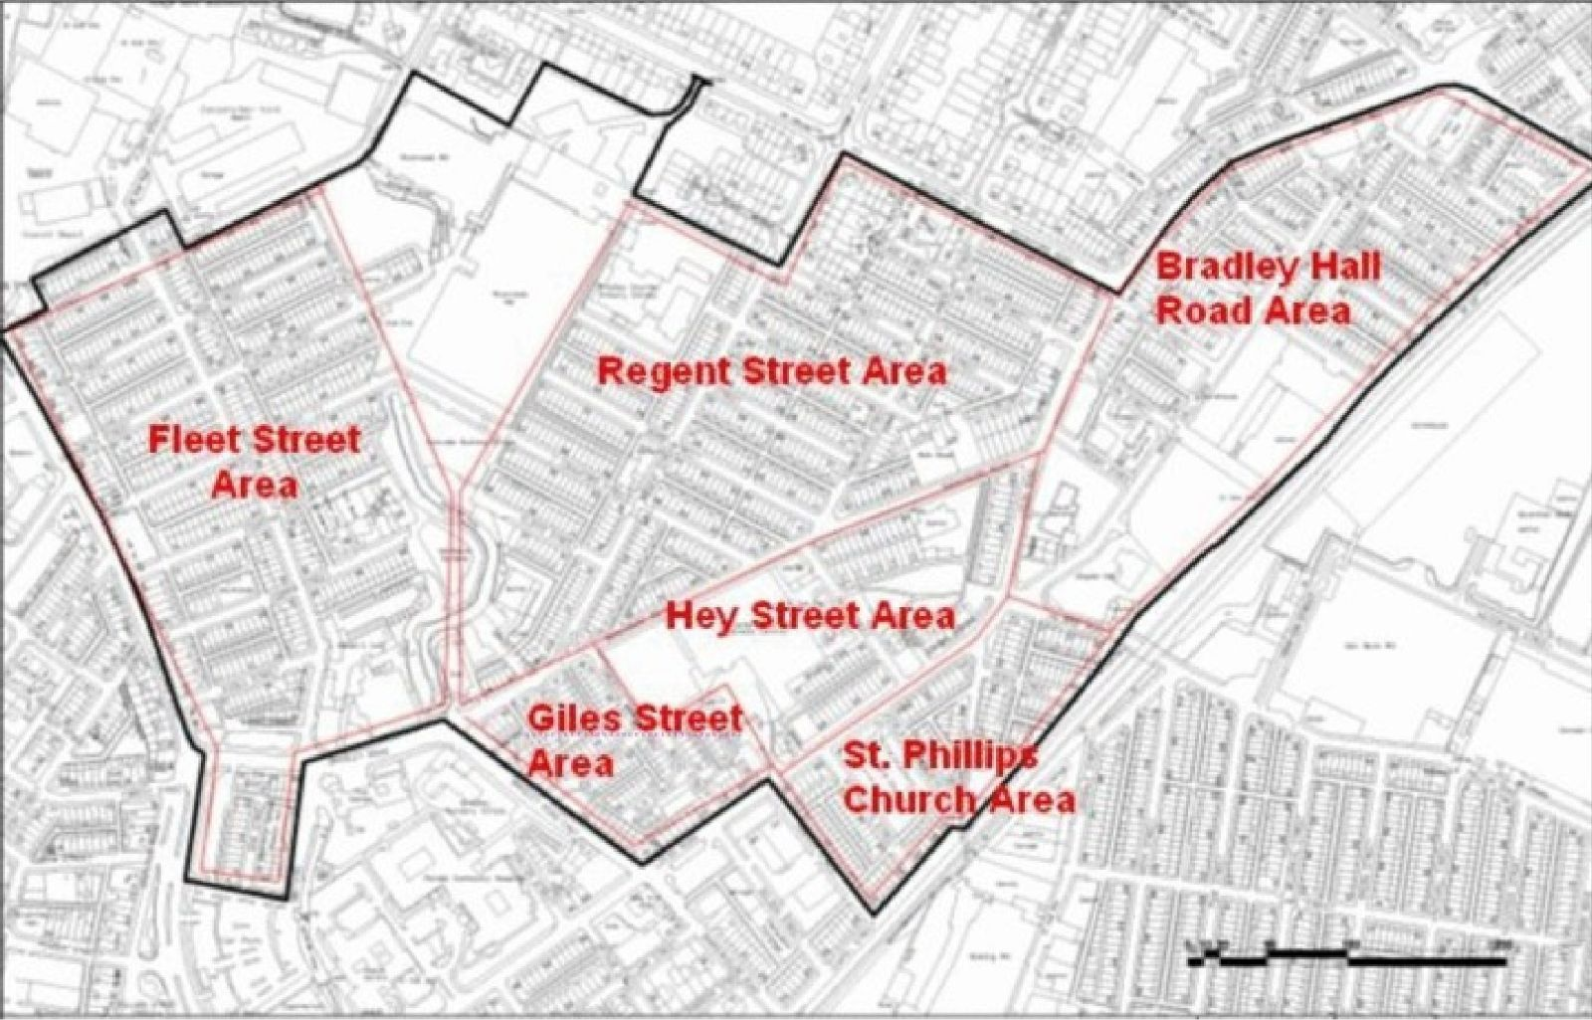Projects must be delivered within the area defined by the Big Local Map or have direct benefit for those residents.

**Who can apply?**

Any group or organisation that operates and/or delivers projects within Bradley and must meet the following criteria:

* The group is constituted/has agreed to terms of reference.
* They have a bank account and/or can work with another group/organisation for example, a school, church that can administer the funds.
* Can demonstrate compliance with statutory requirements e.g. DBS checks for work with children and vulnerable adults etc.
* If the group or organisation is based outside of Bradley, they will have to provide evidence of work in the area.

**How much can each group/organisation apply for?**

Ideas or project applications are invited from £100 to £3,000 maximum.

**All funding must be spent by 30th September 2025 (there is a bit of leeway with this, please speak with us if you need to deliver your project beyond 30th September).**

**What we will not fund:**

* Organisations or activities that support a political party or political policies.
* Activities which promote religious beliefs (please note that religious institutions **can** apply for funding but **not** for religious activities).
* To meet debts or liabilities.
* Funding in retrospective i.e. projects that have already taken place.
* Statutory Services: i.e. Local Authority, Schools, Police etc. **But we will consider activities or projects that partner with schools, care homes, nurseries, support facilities.**
* Individuals: funding is only available to groups, however new groups/projects without a group bank account, can request another established group to hold the funds on their behalf. We will require information about the organisation who will manage the funds for you.
* Groups/businesses with significant reserves.

**How much detail is required regarding the project?**

The application form is designed to be simple to complete. However, the more relevant information that can be included in the space provided, the better. A detailed budget will also be helpful in the assignment of projects. We will require more detailed information the higher the amount of funding you are asking for. We can discuss this with groups before you submit your form. Please use the checklist provided at the end of the application form to ensure you are submitting all the information required for the Partnership to make an informed decision on your application. BPRCVS support is available for those who would like help in completing this form.

What are the deadlines?

* Applications must be submitted by 12 noon on 11th June 2025
* Groups will be informed via email of the Partnership decisions by 25th June 2025
* Payments will be made via BACS by 9th July 2025

**Once the application has been submitted, what happens next?**

The Partnership will make a decision on your application.

If you are successful we will work with you to agree a start date for the project. If you have not been successful with the application we can work with you to develop the proposal and suggest other funding and development opportunities.

For more information about the Bradley Big Local Community Fund and the application process please contact: BPRCVS: email: [heather.starkie@bprcvs.co.uk](mailto:heather.starkie@bprcvs.co.uk) **or** phone: 01282 433740

**Return Applications to:** Post**:** Bradley Big Local, c/o BPRCVS, 62/64 Yorkshire Street, Burnley BB11 3BT **or** Email: [julie.overson@bprcvs.co.uk](mailto:julie.overson@bprcvs.co.uk)

Thank you for taking the time to read these guidance notes and we wish you every success with your application