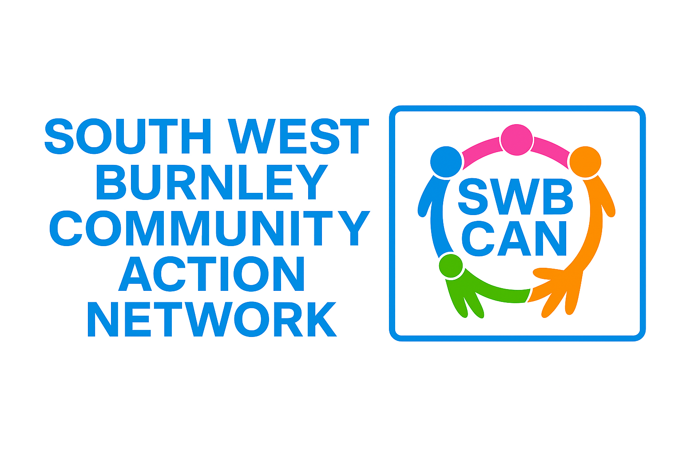
Together We CAN – Fund
Application Pack

1. ABOUT THE FUND
The Together We CAN community Fund has over £6,500 to spend on community projects in SW Burnley. We will support the community to run their own small projects that will benefit the community. Residents, groups, young people, and organisations can all apply — and local people will vote to decide which projects get funded.
SW Burnley Map
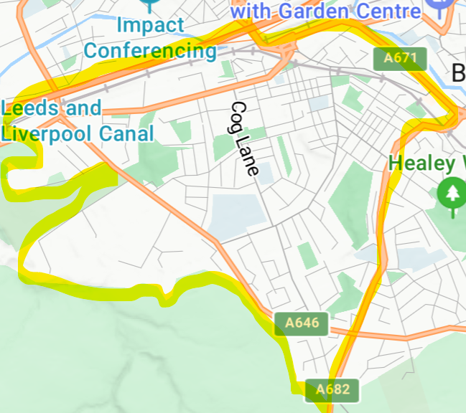
We consider SW Burnley to include the community within the yellow highlights on this map.

This fund encourages:
- New ideas
- Community-led activity
- Projects that bring people together, especially men as we know there aren't a lot of things for men to do here
- Positive activities for local residents
- Practical improvements to the neighbourhood
You can apply by form or video (details below).
Applicants will present their idea to the community at a lunchtime event on 13 June at Basically Cheer (Former Parkside Methodist Church) and the community who attend will vote for the projects that they'd like to support. The winners will find out on the day if their project is successful. Successful applicants will then have until December 2026 to complete their projects.

2. FUND PRIORITIES
Your idea should support at least one of these priorities:

✔ Community Connection
Projects that bring people together, reduce isolation, or build relationships. We welcome project applications from men

✔ Children & Young People
Positive, safe, inclusive activities for young people.

✔ Health & Wellbeing
Activities that promote physical or mental health.

✔ Community Pride & Environment
Projects improving shared spaces, environmental action, or neighbourhood pride.

✔ Skills, Learning & Employability
Activities that build skills, confidence, or job opportunities.
If uncertain, come and talk to us — we are very friendly and flexible.

3. WHO CAN APPLY
Anyone connected to South West Burnley can apply, including:
- Individual residents
- Local clubs and groups
- Schools (for community-facing activity)
- Informal groups
- Young people (under-18s need an adult supporter)
- Charities and CICs with less than £5,000 turnover
You do not need to be an official group with a constitution.
We can help with finances, safeguarding, publicity, and planning.

4. HOW TO APPLY
You can apply in two different ways:

OPTION 1 — SHORT APPLICATION FORM
Fill in the form included in this pack and submit it to secretary@westendburnley.co.uk before the deadline.

OPTION 2 — SEND IN A VIDEO APPLICATION
Record a simple 2–5 minute video using your phone.
In the video, tell us answers to the questions in the application:
- Who you are
- What your project idea is
- Who will benefit
- Why your idea is needed
- What you will spend the money on
- Anything else you feel is important
The video does NOT need to be edited or polished.
A simple selfie-style clip is perfect.
You can send videos via WhatsApp, email, or upload — use whatever is easiest. Send completed videos or applications to secretary@westendburnley.co.uk or drop it off with any of our partners listed above.

NEED HELP?
If you need help with your application — form or video - we will be holding surgeries at Coal Clough library, so you can come down and ask us any questions that you like about the fund.
Dates: 21st April 10-11.30 and 27th 1-2.30
Ask any member of the South West Burnley CAN to help you.
We’re happy to support with ideas, writing, explaining, or submitting:
- Vic - Basically Cheer hello@basicallycheercic.com
- Rachel - Burnley Leisure and Culture: RDavies@blcgroup.co.uk
- Chris or Anna - West End Community Centre - 01282 435865 devworker@westendburnley.co.uk Secretary@westendburnley.co.uk
- Rev'd Kat - St Matthews Church 07397 775388 - revkatgw@gmail.com
- Andrea or Emmy - Valley St Community Centre - 01282 686414 ABushell@calico.org.uk EDickinson@calico.org.uk

5. DEADLINE FOR APPLICATIONS
Drop applications to any of the organisations listed above or send them secretary@westendburnley.co.uk by Midnight, Sunday 10th May
Late applications cannot be accepted.

- THE APPLICATION FORM

Cut and paste this into a new document or straight into an email
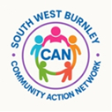

South West Burnley Together we CAN! – Application Form
1. About You / Your Group
Name of applicant or group:
Contact person:
Phone: Email:
Address/Area of SW Burnley:
Applying as: Individual / Group / Youth / Other
2. Your Idea
Project title:
Describe your idea (what you want to do and why):
Who will benefit and how will it help South West Burnley?

3. Budget
Amount requested (£50–£500): £
How the money will be spent:
4. Support & Delivery
Do you want a partner organisation to hold the funds? Yes / No
Support needed (if any):
6. Consent
I confirm this project will benefit South West Burnley.
Signature: Date:

- Supporters
Signatures of people who support this application:
!.

2.

SECTION 8 — For Applicants Under 18
If the lead applicant is under 18, a responsible adult must complete this section.
Name:
Relationship to applicant:
Contact details:
Signature:
Date:

7. VIDEO APPLICATION GUIDE

HOW TO MAKE A VIDEO APPLICATION (2–5 minutes)
Your video should include:
- Who you are
- Your project idea
- Why your idea is needed
- Who will benefit
- How you will spend the money
- Anything else you want voters to know

Tips for a good video
- Use your phone — no fancy equipment needed
- Film in a quiet place
- Make sure there is enough light
- Hold your phone steady or prop it up
- Speak as if you’re telling a friend about your idea
- Show the space you plan to use (optional)
- You can include others (group members, young people, supporters)

Need help recording your video?
Ask any CAN member — we can help film, upload, or talk through your idea.

🌟 LOW-COST PROJECT IDEAS

1. COMMUNITY CONNECTION

🛠 “Men’s Shed-Style” Micro Projects
Low-cost, skill-sharing activities for men to meet and make things together:
- Bird boxes
- Planter boxes
- Upcycling old furniture
- Simple repairs for neighbours
These only need donated tools, scrap wood and a venue.

☕ Community Breakfast / Brew & Chat
Pop-up social sessions at a shared space (library, church hall).
Costs: tea, coffee, biscuits.

🏘 Neighbourhood Clean-ups or “Adopt a Street”
Residents pick a street to tidy together once a month.
Costs: bin bags, gloves, litter pickers.

🌽 Seed Swaps & Growing Meet-ups
Residents meet to exchange seeds, share advice, and grow together.
Costs: seeds and compost.

2. CHILDREN & YOUNG PEOPLE

🎨 Art Club or Street Art Workshops
Activities led by local volunteers or creative young people.
Costs: paint, card, markers.

🎮 Gaming or Retro Games Club
Using donated consoles or low-cost board games as a safe social space.

🏀 Sports Taster Sessions
Street football, basketball, cricket, dance, boxing basics.
Costs: balls, cones, whistles.

📸 Photo Walks or “Our Community in Pictures” Project
Young people photograph positive parts of SW Burnley and create a display.
Costs: printing photos.

🎧 Podcast for Young People
A simple “voices of SW Burnley” youth podcast.
Costs: one low-cost microphone.

3. HEALTH & WELLBEING

🚶 Walking Group or “Walk & Talk” for Men and Families
Short weekly walks around Towneley or local streets.
Costs: minimal for refreshments.

🧘 Chair-Based Exercise / Gentle Movement Class
Perfect for older adults or people with mobility issues.
Costs: volunteer instructor or small equipment.

🥗 Healthy Cooking on a Budget
Cooking simple meals together using slow cookers or one-pot recipes.
Costs: ingredients and small kitchen items.

🧠 Mindfulness for Beginners
Short sessions teaching breathing, calm spaces, and stress management.

4. COMMUNITY PRIDE & ENVIRONMENT

🌻 Street Planters / Pocket Parks
Residents adopt a corner or planter, growing flowers or herbs.
Costs: compost, seeds, a couple of planters.

🧹 Clean-up Days + Kids’ “Mini Clean Team”
Great for mixed ages, teaching pride and responsibility.

🐦 Wildlife Homes Project
Build and place bird boxes, hedgehog houses, bug hotels around the triangle area.

🎨 Community Mural or Pavement Art Trail
Brightens public spaces and builds pride.
Costs: paint, brushes.

5. SKILLS, LEARNING & EMPLOYABILITY

🛠 “Fix-It Club”
A volunteer-led group teaching basic DIY skills:
- changing a lightbulb
- using a drill
- hanging a shelf
Great for men, young people and anyone starting out.

💻 Basic Digital Skills Helpdesk
Residents help neighbours with:
- setting up email
- job searches
- form filling
Costs: none if using library devices.

🧵 Sewing & Mending Group
Fixing clothes, upcycling, making simple items.
Costs: needles, thread, a few donated machines.

📚 Homework / Revision Café for Teens
Run by volunteers or older students.
Costs: snacks and stationery.

🌟 ULTRA LOW-COST PROJECTS (<£100)
Great for small grants:
- Swap shop (clothes, toys, books)
- Family games night
- Community board game library
- Book swap box on a street corner
- Tool library startup
- Community chalk festival
- “Pay it forward” kindness cards to warm people's hearts
- Pop-up tea stall at the park

🌱 PROJECTS THAT BRING AGES TOGETHER
- Grandparents & young people storytelling project
- Intergenerational gardening
- “Bake and Share” sessions
- Board games mixed with digital games
- Memory café with young volunteers
We look forward to talking to you about your project, please get in touch to discuss your idea. Good luck!

